Missionaries and Cannibals Problem
Aim
To implement the Missionaries and Cannibals Problem using Python and find a safe sequence of moves to transport all missionaries and cannibals from one side of the river to the other.
Objective
To solve the Missionaries and Cannibals problem using Breadth First Search (BFS) while ensuring that the missionaries are never outnumbered by cannibals on either side of the river.
Algorithm
- Start the program.
- Represent the initial state as (3, 3, 0, 0, Left).
- Represent the goal state as (0, 0, 3, 3, Right).
- Create a stack and push the initial state.
- Maintain a visited set to avoid revisiting states.
- Pop the top state from the stack.
- If it is the goal state, display the solution.
- Generate all possible valid boat moves.
- Check whether each generated state is safe.
- Push all valid unvisited states onto the stack.
- Repeat until the goal is found or the stack becomes empty.
- Stop the program.
Flowchart
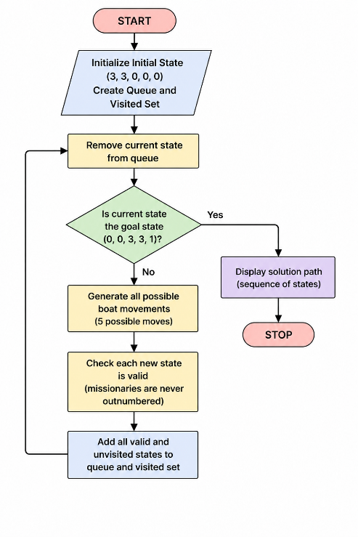

Python Code

def valid(state):
ml, cl, mr, cr, boat = state

if min(ml, cl, mr, cr) < 0:
return False

if max(ml, cl, mr, cr) > 3:
return False

if ml > 0 and ml < cl:
return False

if mr > 0 and mr < cr:
return False

return True

moves = [(1,0), (0,1), (2,0), (0,2), (1,1)]

def dfs():
start = (3,3,0,0,0)
goal = (0,0,3,3,1)

stack = [(start,[start])]
visited = set()

while stack:

state, path = stack.pop()

if state == goal:
return path

if state in visited:
continue

visited.add(state)

ml, cl, mr, cr, boat = state

for m,c in moves:

if boat == 0:
new = (ml-m, cl-c, mr+m, cr+c, 1)
else:
new = (ml+m, cl+c, mr-m, cr-c, 0)

if valid(new):
stack.append((new, path+[new]))

return None

solution = dfs()

if solution:
print("Solution Found\n")
for i,s in enumerate(solution):
ml,cl,mr,cr,boat = s
side = "Left" if boat==0 else "Right"
print(f"Step {i}: Left({ml},{cl}) Right({mr},{cr}) Boat={side}")
else:
print("No Solution")
Output

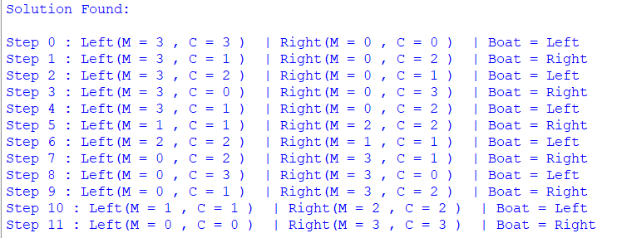
Result
The Missionaries and Cannibals problem was successfully solved using the Breadth First Search (BFS) algorithm. The program finds a sequence of valid states that safely transports all missionaries and cannibals to the opposite side of the river.
Conclusion
The program successfully demonstrates how state-space search and BFS can be used to solve the Missionaries and Cannibals problem. The solution ensures that the missionaries are never outnumbered by cannibals on either side of the river.

